Programming 6211 Assignment (Final)

2016

Adrian Beukes 15002426

**Content**

Specifications ………………………………………………………………………..2 Purpose Functional Requirements

Documentation ………………………………………………………………………..3

Test Data ………………………………………………………………………..5

Error Handling …………………………………………………………………….....11

Help ………………………………………………………………………..11

Feedback ………………………………………………………………………..12

Improvements ………………………………………………………………………..12

**Specifications:**

Purpose:

This project is to do a stock system for a store. The store I choose was an extreme sports store. The main features of the program is to allow the user to browse through the category’s and choose which one they would like to view, once you selected a category you will be able to view the products they have in their store available, and to order more in the case where the stock might be low, or add a new product item, or even delete an old product. Added feature, are the functions where the user can also see stock from the start of the month, and how many were sold during the month.

My program works on a windows form application, with the integration of classes where it would receive input from a user, and use that input to give the wanted outcome/reports.

Functional Requirements:

In my form you would find examples of the following

Functions from my 1st assignment all the way through to my 3rd assignment where all incorporated into my final design. For my final assignment the only requirements where to be able to:

* View stock
* Update Stock
* Add stock
* Delete stock

All of the above which was met, with the added functionality, and great design.

**Documentation**

Flow Chart:

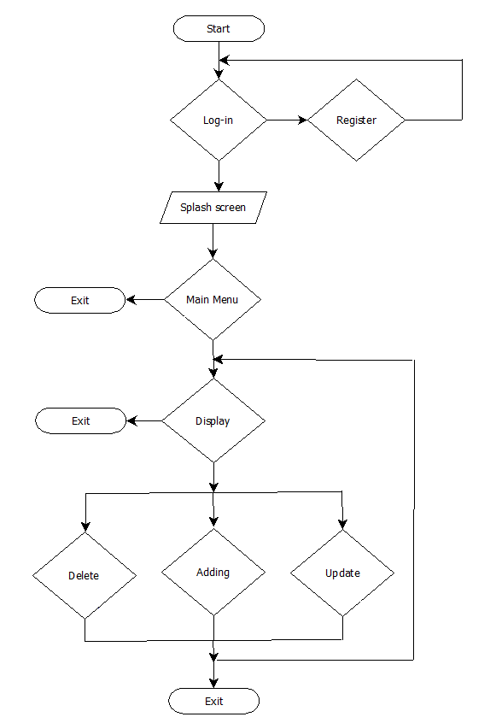

Class Diagram

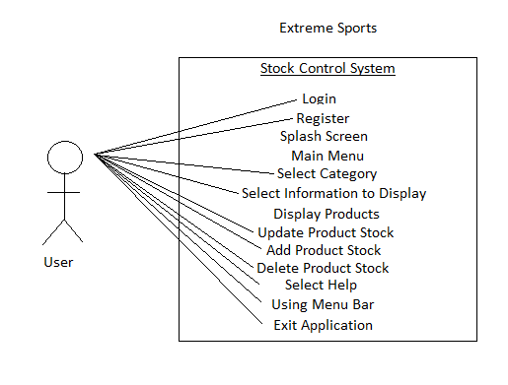

**Test Data**

A few screenshots of my program will follow, with explanation of what’s happening at each stage, as I progress in order to test it:

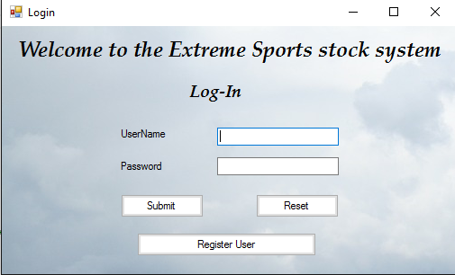

This is the Login Form, here you can sign in, reset fields in case of spelling error, or you have the option to register new users

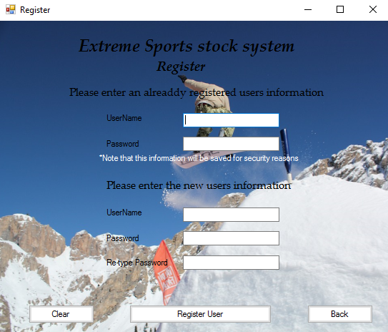

This is the register form, you need a valid user to enter information, before you can register as a new user, for security reasons, and the user registering you data will be recorder, in the case of corruption, there is also a function of retyping the password, to check that the new user has the correct password.



Splash Screen With a progress bar and percentage amount till completion

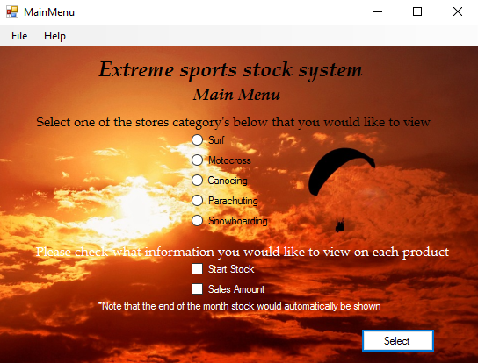

Once you successfully logged in, you will see the main menu, which gives you a menu at the top, with files in it for, log-out, exit, and a help function. You then have the decision which category you want to view with radio buttons, and also what information you would like to view about each product with a checkbox option.

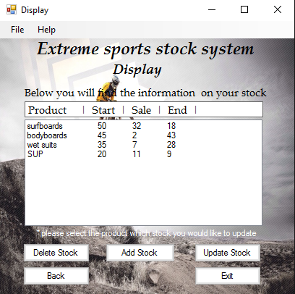

The display form, gives you all the information about the categories you selected, which is all imported via initialization in main menu and a text file. The table headings is changeable depending on the checkboxes you selected, and the information self is then selectable for updating

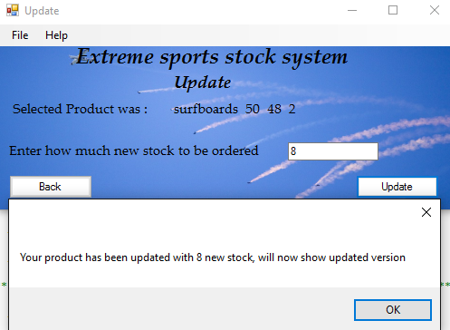

This is the update form, which shows you which product you selected to be updated, it then runs it against an array to make sure the correct field is updated, and it updates the last field, end stock with the newly added stock, it displays a message on how much it updated with, and throws you back to the display form, reading information from the updated text file

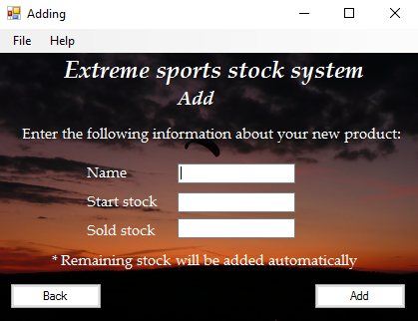

This is the form for adding new products, you have to enter the name of the new product, the start of the month amount, and how much of the product was sold during the month, and the end of the month will be automatically calculated.

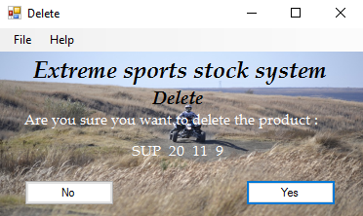

The delete form is a confirmation to make sure you would like to delete the selected product.

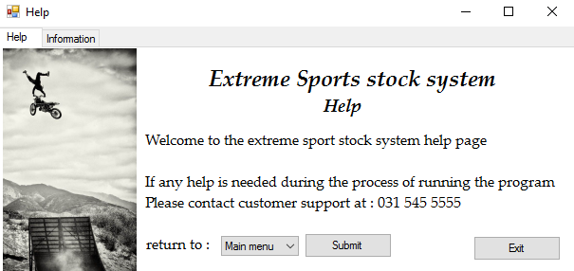

This is the help form, which is accessible from the main menu, display and update forms, it has a tabcontrol, which allows you to see help, or information about the program, the information tab is shown below. In each of them, you have the option to exit, sign-out, or go back to the main menu

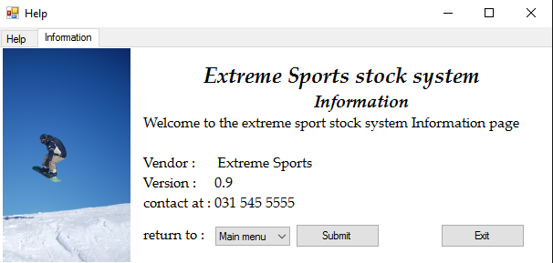

**Error Handling:**

For my error handling I added Booleans with while loops, so in case the incorrect information was entered, it will repeat asking the question

There was also if statements used to check that values entered for ordering are always positive, which will show you an error message

The login also has catches to see if correct information is entered, and you can’t enter the program with wrong information

**Help:**

This is a guide that would take you step for step through the application.

On opening the application you will find yourself at the login page, where you have to enter the correct credentials and password to receive access to the application, else you have the option of registering a new user for the system, although, you do need a valid already registered employee to help new employee’s with registration, as there data is needed in creating the new employee data, also note their information will be stored in order to prevent any fraud.

After successfully logging into the system, you will find yourself with the main menu, where you will have the option of selecting a category, and also which information on the selected category you want to view, should it be start of the month stock, sales during the month, or remaining, which is automatically always selected.

After making your selection options, the display screen with all the products and their information will be displayed, here you can select any product from the list, and update the stock in the case of low stock being left at the end of the month

If you selected a product and clicked update, you will be taking to a new screen, where you can enter the amount you wish to order and if successfully entered an amount, you can press the update button, and a notification message will display what you updated and with how much and bring you back to the display screen where you can repeat the process

Each screen has a back button option which will take you to the previous screen.

Each screen also has a help option in the menu bar, which will take you to the help and information screen and from there you can exit or return to the main menu or log-in screen

In each form you will also find a login and exit underneath the file menu bar, which will initiate that process depending on the selected choice.

**Feedback:**

On my previous assignments I received feedback to the following for my final assignment

The major issues involved:

* Naming of form items
* Inconsistent commenting
* Redundancy

**Improvements:**

For my final assignments I improved my project by looking at the naming of form items

l also added more comments to make it as consistent as possible and describing each action that is happening in the code

I also looked at my classes and try to expand the uses of them

I also added extra functionality to my code

Extra functionality I decided to add:

* option to delete Stock
* option to add stock
* Added splash screen
* Option on viewing of start of month stock + sales during the month